Non-linear Hypotheses

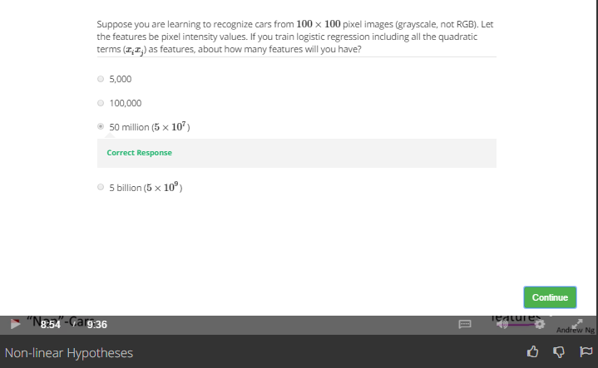

It says quadratic, so

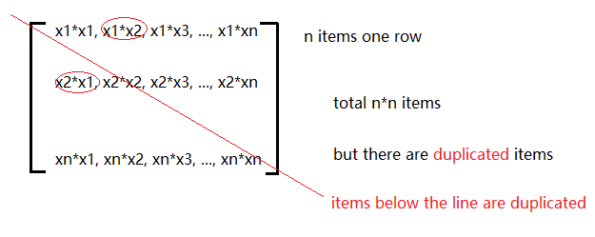

Total = n\*n/2